# Workshop: Book Store

Workshop for the ["ReactJS Fundamentals course at SoftUni"](https://softuni.bg/opencourses/reactjs-fundamentals)

## Overview

You have to create a **ReactJS application** for a **book store**. In the application you must have **admin functionality** (**creating** a book, **approving purchases**, **editing** and **deleting** books). The **logged users** can **purchase books**, leave **reviews**, **like** a book, have a **cart** with currently purchased books. When opening their cart, they must be able to see **all purchased books** and they must be able to **complete their order** (after that an **order is created** and the user must wait for admins approval). The users should be able to see **all of their orders** in a separate view with detailed information about them.

## Server

You are **given** a server with all the **models** and **configurations** you will need to create your react application. **Explore the provided server!**

### Models

* **User** – email, username, password, roles
* **Book** – title, genres, author, description, price, likes, reviews, imageUrl
* **Orders** – creator, products(books), date, status ("Pending" || "Approved" || "Delivered")

### Routes

* **'http://localhost:5000/auth/signip'**
* **'http://localhost:5000/auth/login'**
* **'http://localhost:5000/book/create'**
* **'http://localhost:5000/book/edit/:id'**
* **'http://localhost:5000/book/all'**
* **'http://localhost:5000/book/review/:id'**
* **'http://localhost:5000/book/like/:id'**
* **'http://localhost:5000/book/unlike/:id'**
* **'http://localhost:5000/book/delete/:id'**

## Structure

### Navigation

In the navigation bar, you must have the following links:

* **Home** – view the home page with all the books
* **Login, Register, Logout**
* **View orders** – logged-in users only
* **Cart** – logged-in users only
* **Create book** – admin only
* **Pending Orders** – admin only

### Home

In the home page, list **all existing** books. For each book **display** its **cover image**, the **description**, **buttons** (**Admin: edit, delete; Users: details, order**)

### Login/Register

Create a **form** with all the **needed information** for **creating/logging** **a user**

### Orders

Here you should show **all orders** of the currently logged user. An order is, when a **user has added** **one/many books** in his **cart**, and **has pressed** the button **"Checkout"**. Display the **all orders** in a **table** with the following **columns**:

* **Order**: the number of the order
* **Date**: the date the order was created
* **Total**: the total price for the order (all books)
* **Status**: the current status of the order (default: pending)
* **View**: button to see the details of the order (create a **separate view**, which displays the **content** of the order: **all the books with title, price**)

### Cart

Here you have to display **all the books** that the **currently logged user** has added. You should have a **"Checkout"** button, which **clears the cart** and **creates an order**. In the bottom **display the total price** for **all the books** in the cart

### Book Details

Display **all the information** about the book, add a **"Like"** button and a separate paragraph showing **all the likes of the book**, add an **"Order"** button, which **adds the current book** to the **cart** of the user, add a **textarea** and a button **"Submit Review"**. Add a section to **display all the reviews**

### Create Book (Admin Only)

Create a form requiring all the information you need to create a book

### Pending Orders (Admin Only)

List all the **pending orders**, with **some information about them** and a button **"Approve"**. When the **button is clicked**, the **status** of the order **must change**.

### Edit Book (Admin Only)

Create a **form**; fill it with the **info of the book**. When clicking on the **"Edit"** button, **submit all changes** (if any)

### Delete Book (Admin Only)

Create a **form** with **disabled inputs**. When clicking on the **"Delete"** button, **remove the book** from the database

## Sample Pictures

### Home Page

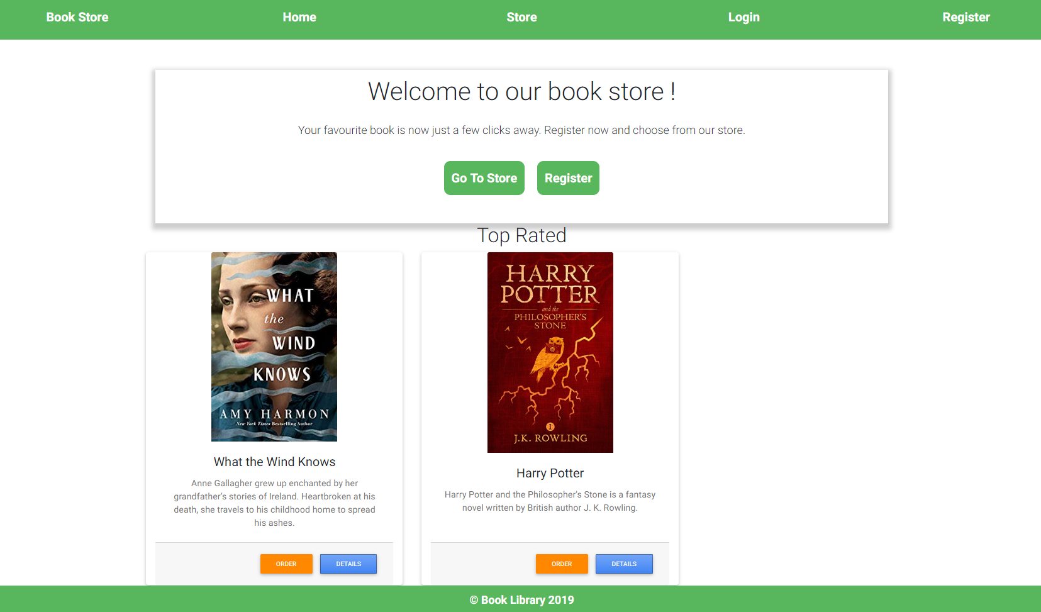

### Register

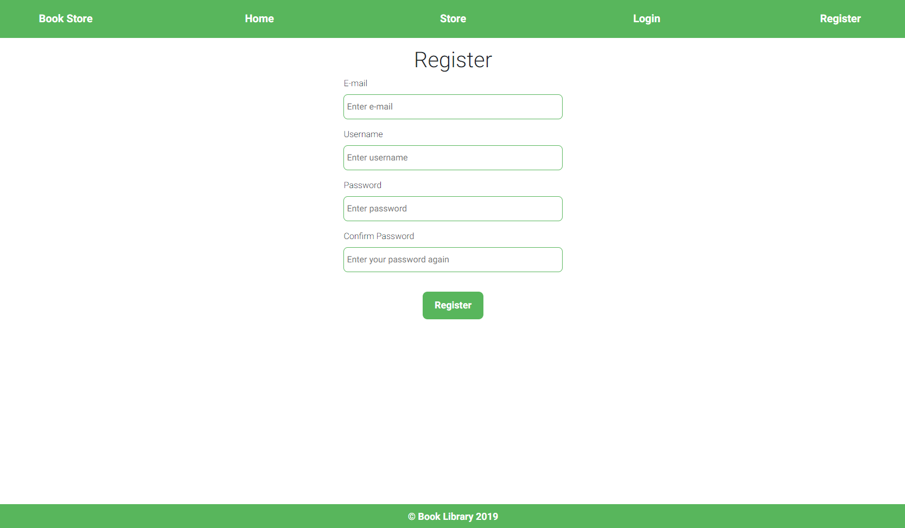

### Login

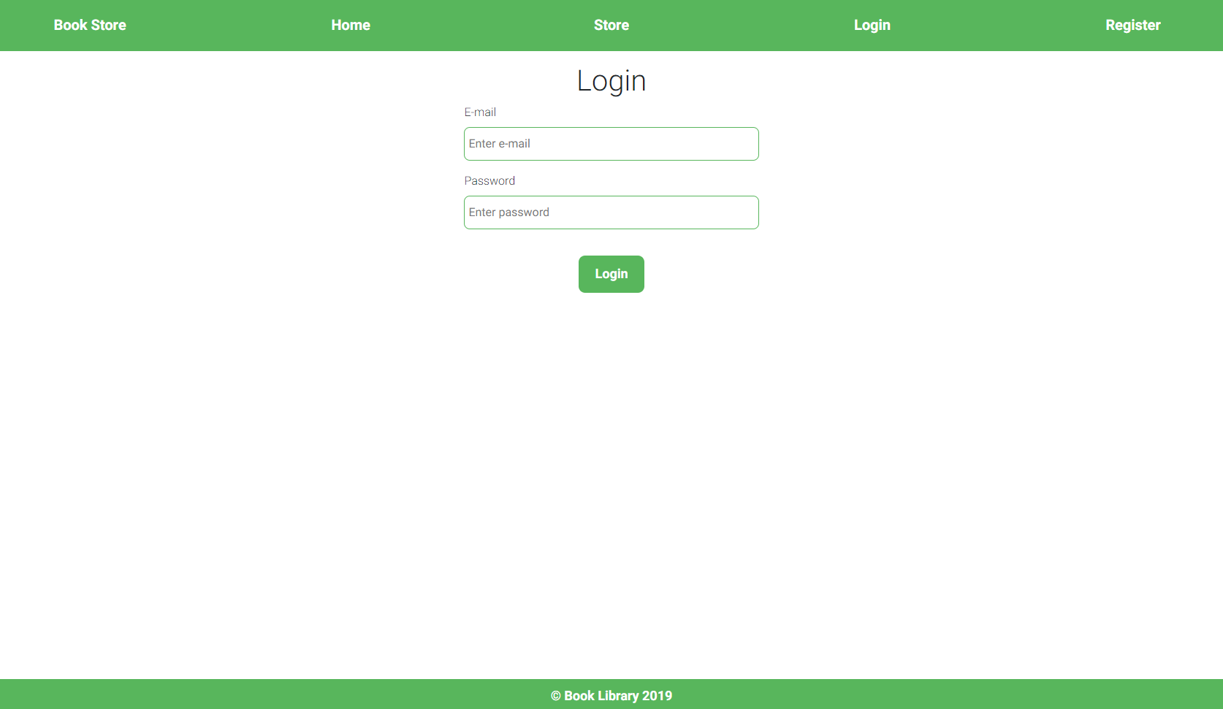

### Create Book (Admin Only)

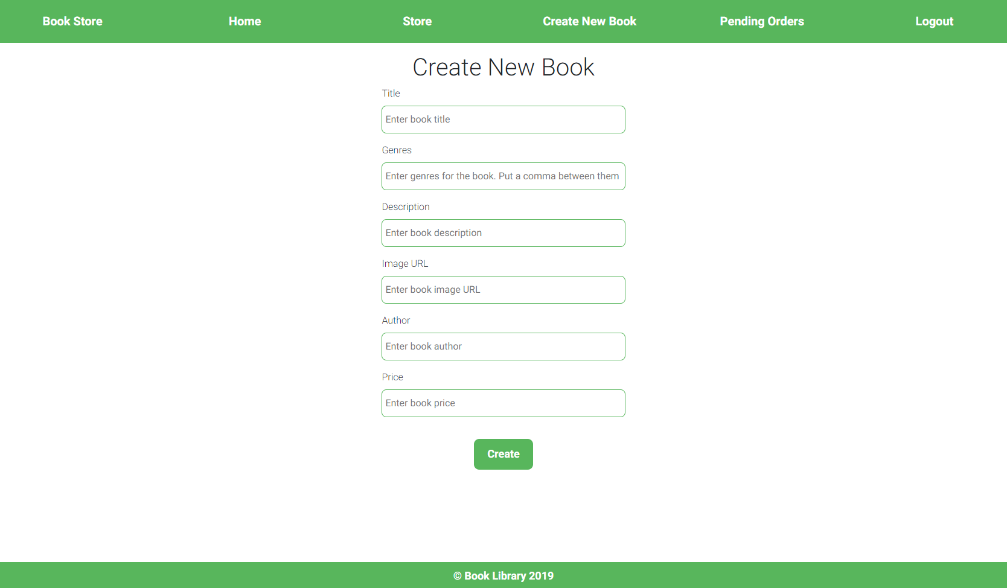

### Details

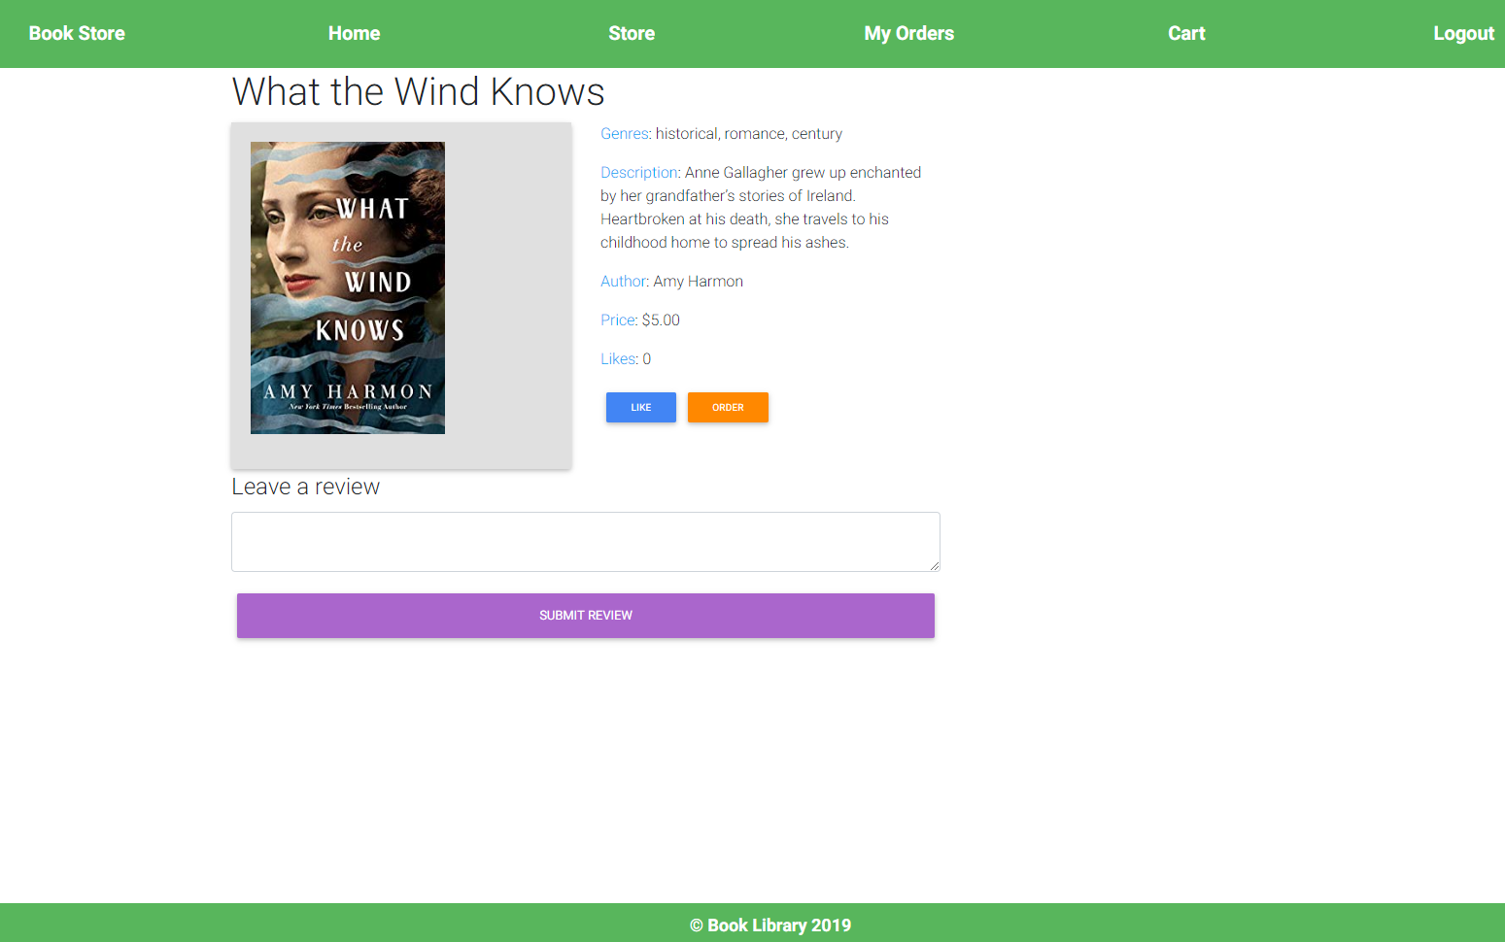

### Cart

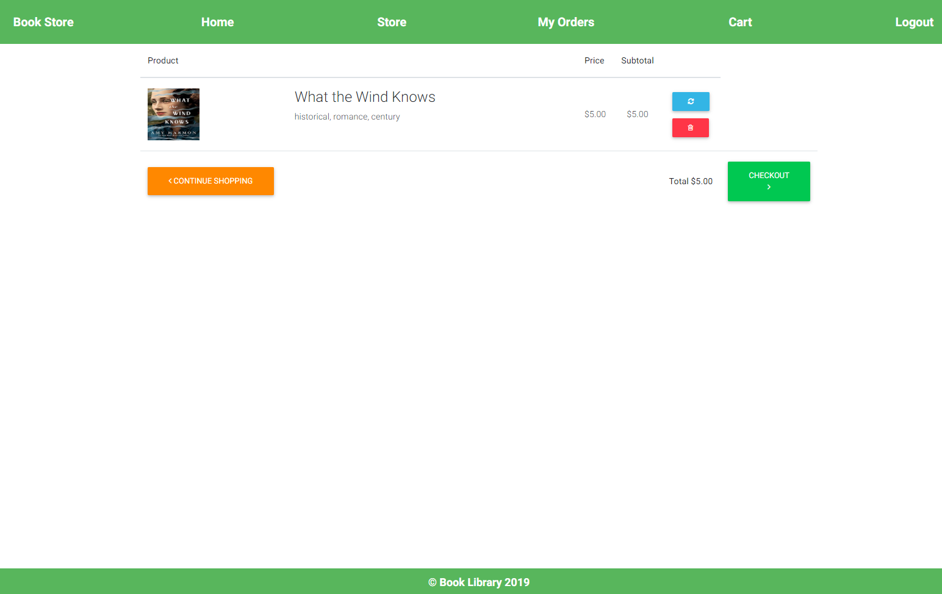

### Pending Orders

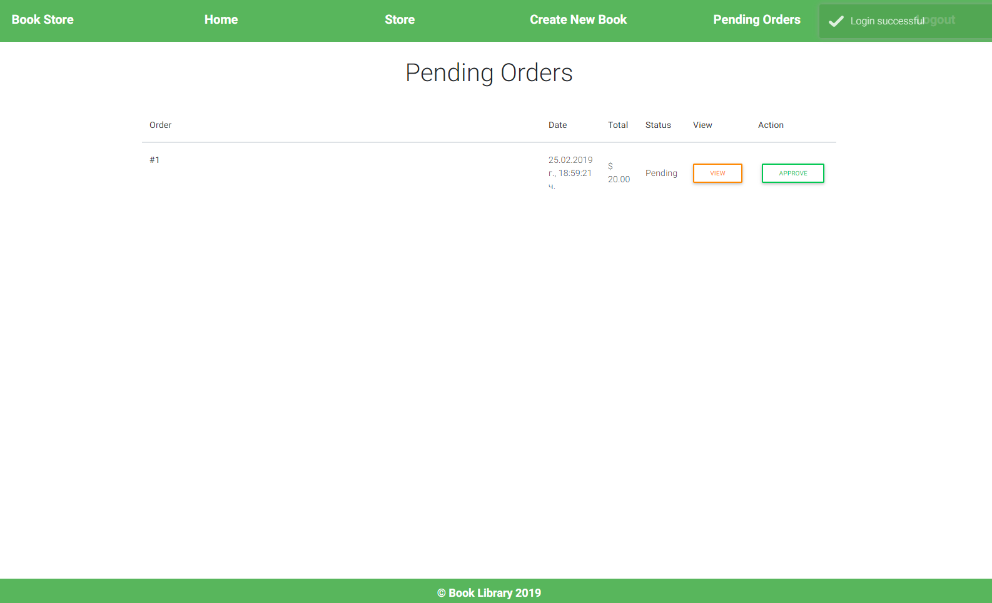

### My Orders

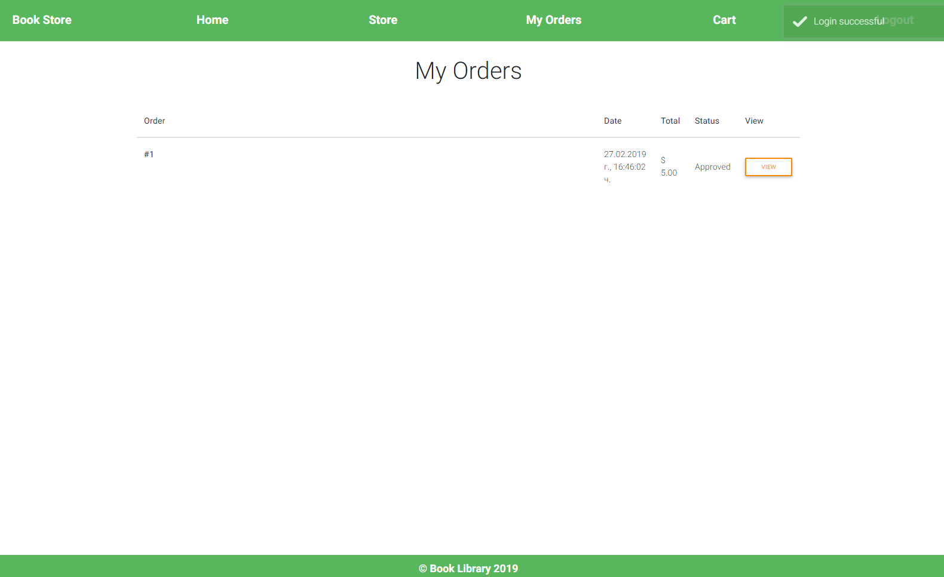

### Store

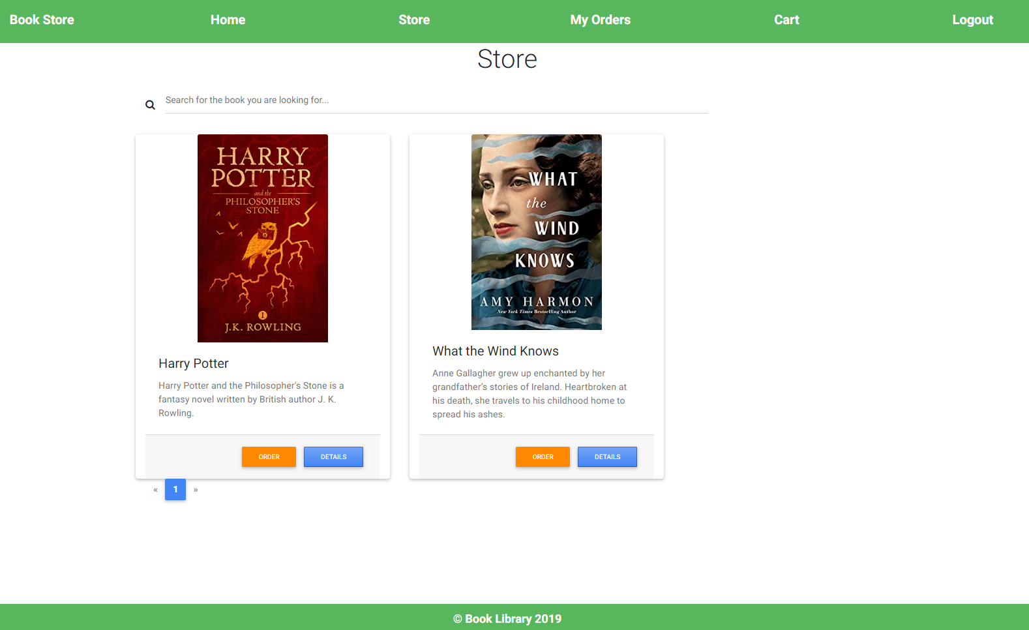

## Implement Error Handling and add Notifications